**Assignment #6**

**Introduction to Linux**

**Ammad Ali**

**Task:**

Welcome to the magical world of Harry Potter! You have been chosen to embark on a wizarding task that involves the mystical powers of MySQL. Your mission, should you choose to accept it, is to create a magical database and wield the spells of data manipulation. First and foremost, conjure a new database using MySQL, and let your creativity flow as you decide the name and theme of this enchanted realm. Once created, infuse the database with a dummy table of your choice, filling it with bewitching data that suits your magical inclinations. Next, grant access to a special user within this realm. If the user already exists, extend their magical privileges to access the database. If not, summon a new user into existence, and entrust them with the keys to this mystical domain. But remember, in the wizarding world, accidents happen. Cast a protective spell by creating a backup of the enchanted database. This backup will act as a time-turner, ensuring that even if the forces of darkness strike, your magical data remains safe. Now, prepare for a challenge. Summon your courage and use your wizarding prowess to delete the database you've created. Fear not, for this is but a temporary vanishing act! With the power of your backup, work your magic to restore the database to its former glory. Your journey through this magical task will test your skills as a true wizard of data. Be wise with your commands and incantations, for the fate of the database lies in your hands. May your MySQL spells be accurate, and your magical database stand strong against all odds. Wizards and witches, the time has come to weave your MySQL magic. Unleash your powers and make this database an enchanting marvel in the realm of Harry Potter! Best of luck on your fantastical quest!

**Solution:**

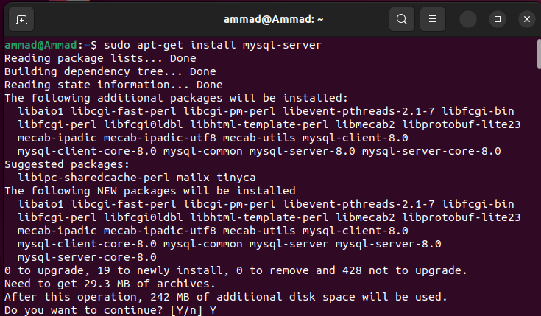

First of all, I installed MySQL-server using apt-get

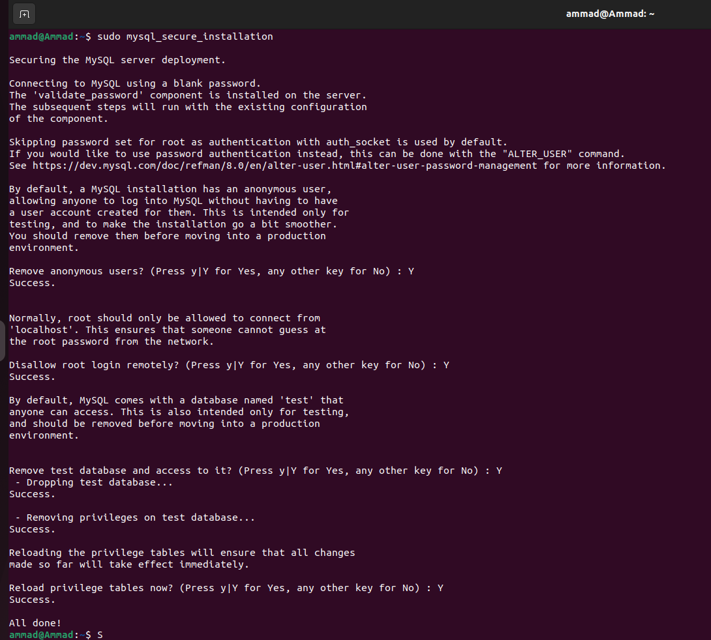

Setting up the default setting for the SQL Database.

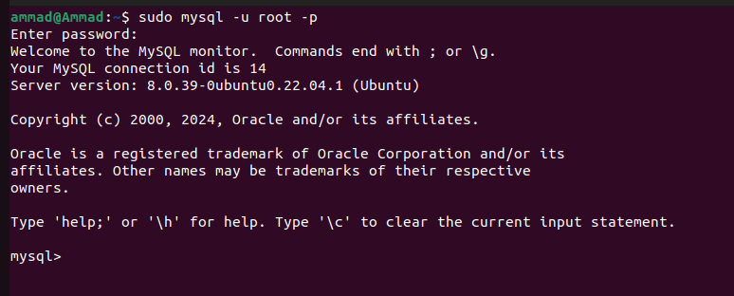

Logging in as root user in the Database

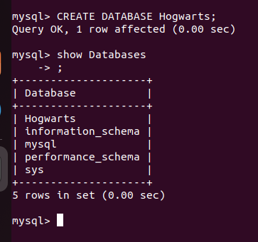

Creating a Database named Hogwarts.

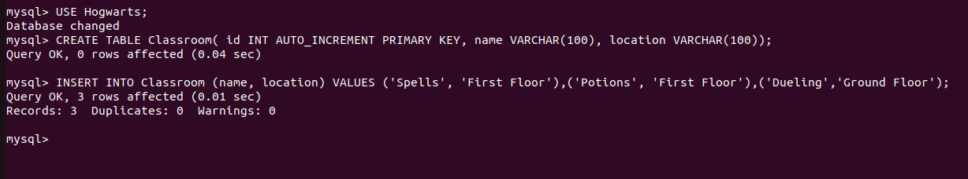

Using Hogwarts Database and then creating a table named Classroom in it. The first column is ID that is the primary key and will be incremented automatically. The second column is the name of the classroom and the third column is the location of the classroom.

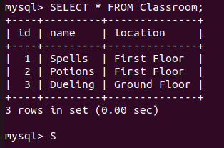

As we can see, the data is entered in the table.

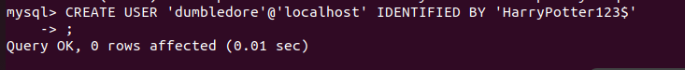

Creating a user named Dumbledore and giving him a password.

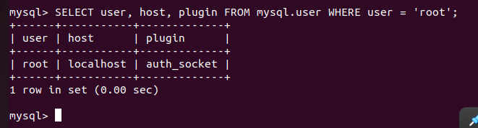

This screenshot shows that we can log in with an empty string password if we use sudo mysql command from our local machine which means the database isn’t secure.



To make it secure, I ran the ALTER USER command and provided the root user with a password so now even if we login to MySQL using sudo mysql, it will ask for a password set for the root user.

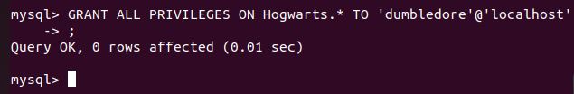

Granting all the privileges to the user that I had created previously.

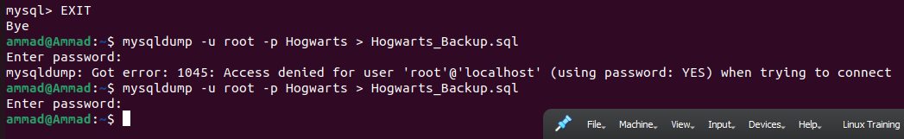

Now, I exited from MySQL and created a sql dump that is used to back up databases. I named the backup file Hogwarts_Backup.sql and the database I backed up was the Hogwarts database that I had previously created.

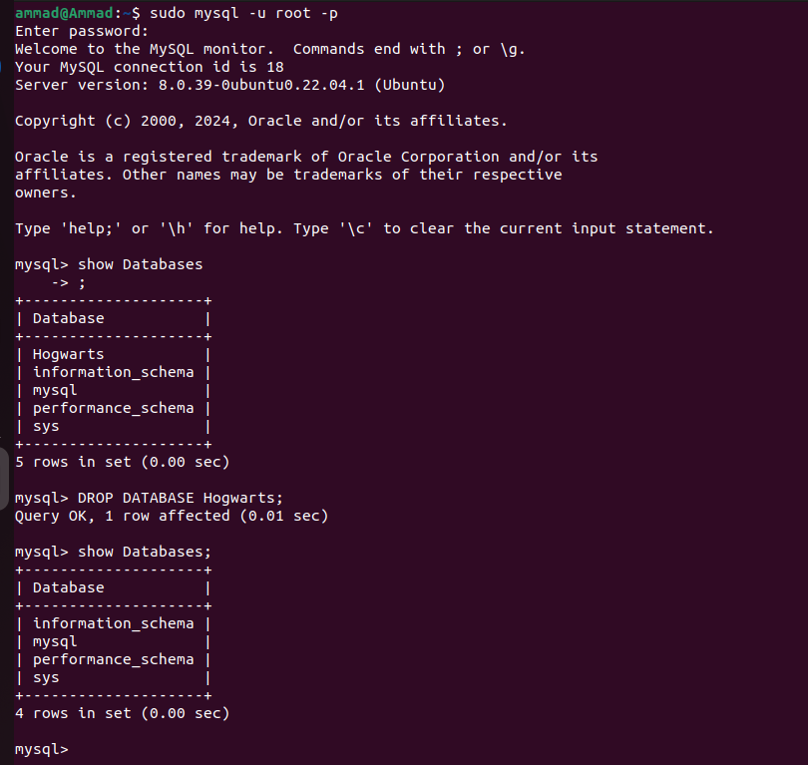

Logging back in to MySQL as root, we can now drop the database that we had created and upon running show databases again, we can see that the database Hogwarts is deleted.

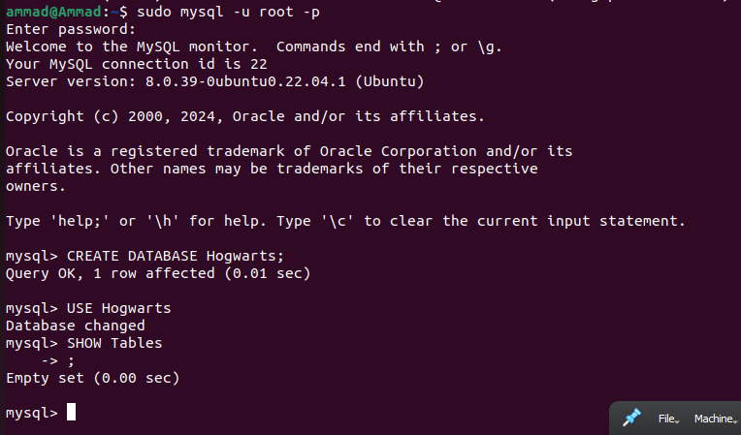

Now if we want to restore the backup that we had created, first we will need to create a database to which we will be restoring the backed-up database to. I logged in again and created a database with the same name Hogwarts. We can see using the SHOW Tables command that the database has no tables in it.

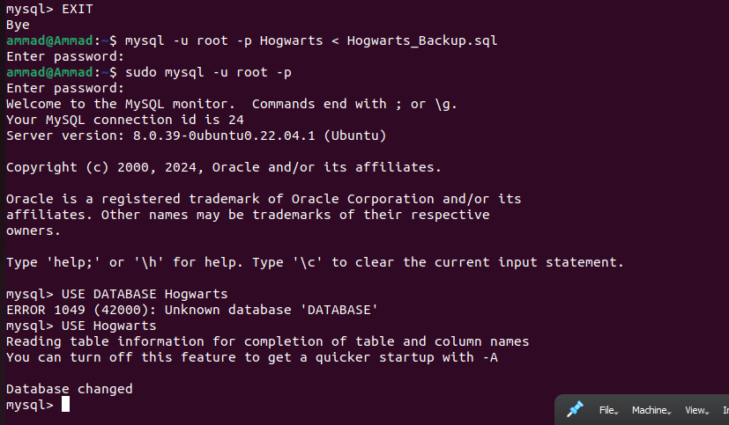

I then exited from MySQL and restored the database, with the help of the dump file, that I had previously deleted. I then logged back in to MySQL.

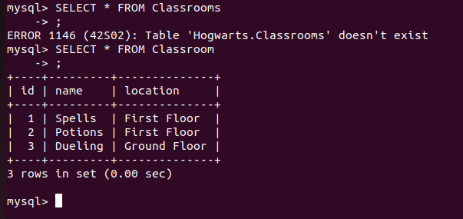

Now running the command SELECT * FROM Classroom, we can see that there is a table named Classroom in the database and it has the data that I had entered in it previously.